NYPLProject Document

### 

### 

### 

### 

### Date: 2022-11-27

### Name: Danfeng Wang

1. Project Code source:
2. Full details are in the **“README.md”** file under code source. This web application includes an API and a web UI side.
3. To test it, you can follow the instruction in **README.md** file via <http://127.0.0.1:8000/> or call the api [http://127.0.0.1:8000/nyplapi/[str:title]/search](http://127.0.0.1:8000/nyplapi/%5Bstr:title%5D/search) directly. Please note, please add the token before start the server:

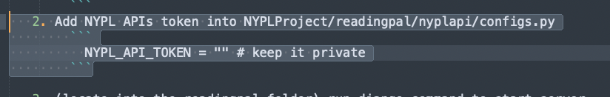

1. Some test screenshots:

